**BubblePlay: An interactive, human-powered, full-body experience with soap bubbles**

**Johanna Lundkvist, jolundk@kth.se   
Ioana Cotutiu, cotutiu@kth.se  
Celine Mileikowsky, celinemi@kth.se**

Project in Physical Interaction Design and Realization  
KTH Royal Institute of Technology

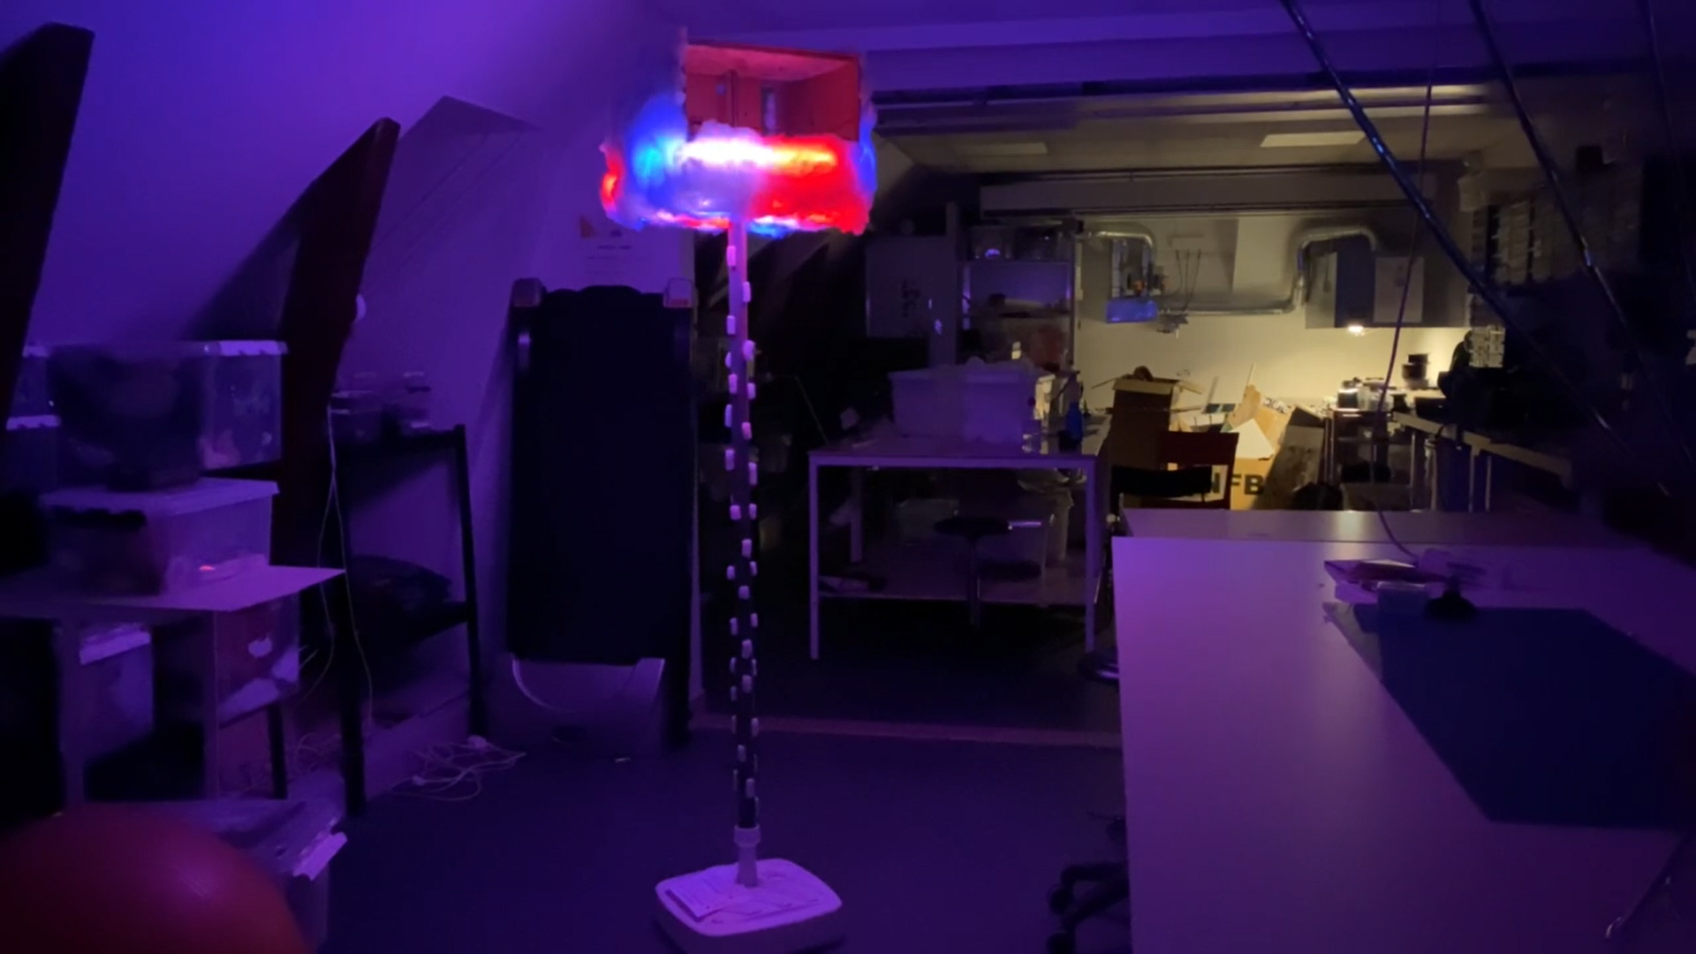

**Abstract**

This paper describes the design process and construction of an interactive play equipment named BubblePlay. Outdoor play and open-ended play is essential to children's development. To make such play more attractive during cold, dark winters, we aimed to include interactive elements and lights in our design. As a result of multiple design iterations, the human-powered machine BubblePlay was built. It functions by twisting a pipe to create bubbles and is decorated with LED-strips. A picture of the final product can be seen in Figure 12.

**Author Keywords**

physical interaction; human-powered; outdoor play; bubbles; full-body interaction;

**Introduction**

Outdoor play is crucial in a child’s development, both for learning [1] and to develop their socialization skills, risk-assessment, and self-esteem [2]. Despite this, the time children spend playing outdoors has diminished, giving time to structured extracurricular activities and use of technology [3]. It is therefore important to encourage parents and children to make time for outdoor activities and to make them more inviting and exciting to participate in. However, during the long winters of the north, outdoor activities are limited by darkness, rain, snow, and ice. For this cold and dark environment there is a need to develop and bring in interactive elements to playgrounds in order to add new dimensions to the existing play during the winter, and potentially help and encourage children to stay active year-round.

**Background**

Playing with bubbles, more specifically soap bubbles, is a common activity with children, and has been proven to have a positive effect on children experiencing distress, anxiety, pain and fear[4]. For these activities, bubbles are often produced by manually blowing on a soapy wand, or with a handheld battery-driven device. Aside from these, bubbles are rarely used in public spaces. One design by Lee et. al. [9] introduces bubbles into the public space, by “bursting bubbles at passersby to invite serendipitous interactions”.

In regards to interactive playgrounds, one study by Veitch et. al. looking at children's ratings of different playground equipment, it was found that interactive features, e.g. equipment that lights up or makes sounds, was rated higher than other equipment [8].

According to the guidelines set by Amouzegar et. al. [6], there are many factors to consider when designing interactive playground equipment for children, including for example:

* Designing for full body movements
* Designing for achieving the feeling of success
* Games should allow for grown-ups to participate
* Equipment should invite cooperation between children, without impacting others negatively
* Colors should be high-contrast and harmonizing
* There should be spaces aimed at touching, such as sand or water
* Playgrounds should be designed to meet the demands of people from different cultures and societal classes.

A study done by Talarowski et. al. discusses the advantages of not fencing off a playground from other areas in a park but instead letting the playground be a part of the surrounding park. This allows for guardians and people of other age groups to participate in play and to do other activities while the children play [7]. Free outdoor play has been proven to have a positive effect on the temperament of children [5].

**Approach**

Our vision with our design and physical interaction project was to create a social, and sustained activity that emphasizes open-ended and sensory play for young children. The key question that we asked ourselves was thereby how we potentially could design and create a collaborative, playful, and active experience, in the given design space of a winter playground. Furthermore, we also wanted to explore the potential of incorporating human-powered aspects into the play action and activity to highlight play patterns of physical, explorative, sensory, and social play? Besides focusing on designing for a sensory experience, we also asked ourselves how we could create a visual experience by including LED lights and possibly create a light phenomenon to further explore and diversify the possible interactions with the design. The incorporation of lights we also argue could have the potential of benefiting and enriching the experience in the naturally dark environment of a winter playground in the north.

**Methods**

*Ideation and Brainstorming*

For this project, we did a lot of brainstorming, both online in the online whiteboard platform Miro [10] and in-person in secure and responsible settings following the recommendations for the COVID-19 pandemic as given by Stockholm County (as of February through March 2021). A mood board was created early in the process, which can be seen in Figure 1. A lot of the ideas were produced when testing and feeling the materials in real life. Throughout the course, we received continuous feedback in weekly meetings from supervisors and other project teams, which was also used to further develop and improve our design. The course supervisors also encouraged us to visit playgrounds in the dark as a way for us to explore the environment and setting that we were designing for. The experiences and insights from these activities were discussed and used in the design of this prototype.

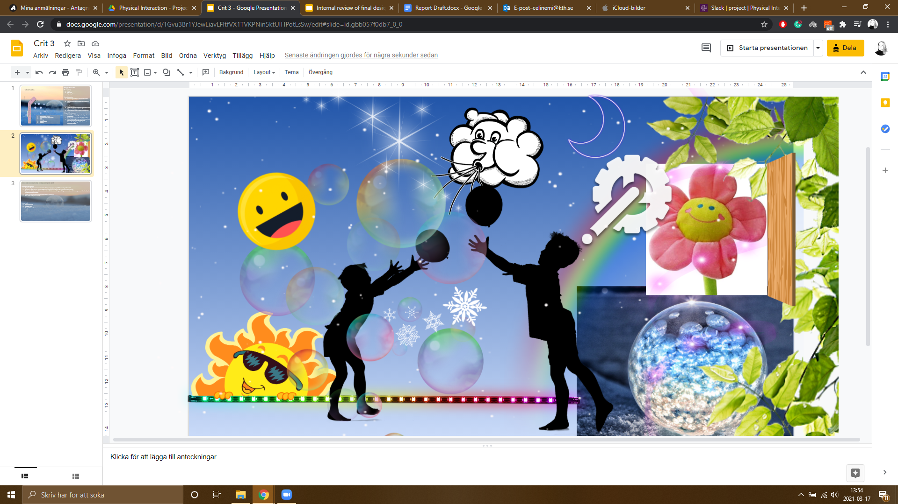

*Figure 1 Mood board for the project*

*Role Play and Body Exploration*When we had constructed the basic elements, a box, and a hoop, we tried out what it might feel like playing with the design, see Figure 7. This was done once more when the full construction was assembled and functioning.

**Design Concept**

During the process of designing BubblePlay, we ended up doing 3 major design iterations over the time period of six weeks. In this section we will describe the iterations, starting from the first one. six weeks. In this section we will describe the iterations, starting from the first one.

*First Iteration*

The main design is based on building a straw-looking tower (approximately 1-1.5m high) in wood, which will hold a bubble machine at the top (with a slight angle) so that the bubbles have the possibility of “falling”. Figure 2 (left) shows a simple illustration to capture the idea of the design of the first iteration.

The tower body:  
The materials planned to be used to create the body of the design is wood, to illustrate and capture a feeling of a “nature” element. The body of the tower should also have LED-lights attached to it, to light in the darkness of the winter playground. The tower body will also have a turning wheel attached to it, the wheel is the element that will be used as the foundation for the human-powered feature.

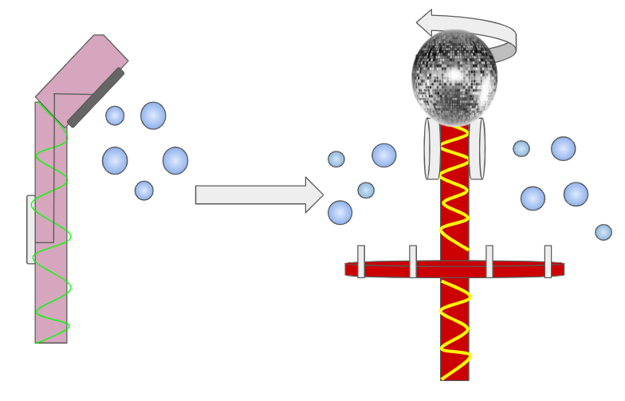

*Figure 2 The first design for the machine (left) was changed during the construction of the first prototype iteration to the design seen on the right.*

The bubble machine:  
The design of the bubble machine is built upon a human-powered turning wheel which is, in our design, supposed to act as a mechanical motor for turning a circular plate made of a vinyl disc/ plexiglass or a similar waterproof material with holes (the holes in the plate are used to create the bubbles) in different sizes, see Figure 3. The circular plate is then supposed to be turned into a non-toxic and biodegradable soap bath to pick up soap-solution in the holes of the circular plate. Behind the circular plate, and built inside of the tower, is an electrical, motor-driven fan placed in order to blow the soap off the turning wheel. Surrounding the contours of the plate a LED light strip should be attached.

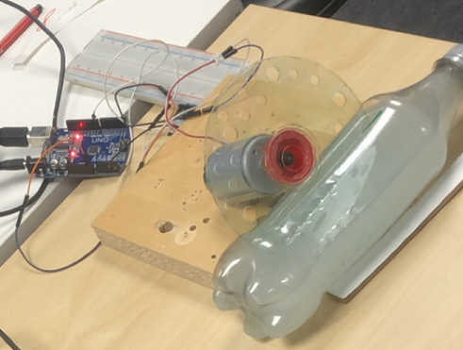

*Figure 3 First working prototype of the bubble maker*

Activation of interaction:  
The fan and lights should be activated using sensors to register approaching movements, this, we argue, will prevent our design from using unnecessary amounts of energy. As someone approaches the bubble-tower the sensor should react and fade in the light of the LED strips and start the fan. The bubbles are then created using human power to spin the plate, to make it rotate in the soap-bath before the fan blows out the bubbles.

Design and Security aspects:  
To make the design of the tower more suitable for different environments and playgrounds we will be experimenting with different imaginative ideas of the shape and looks of the tower, such as making the plate as a smiley-face and attach arms to the tower to make the whole design as a cartoon figure or make it look like a flower, snowman or similar!

Regarding the security aspects of the design, we are focusing on, for now, two aspects:

1. Make the tower secure: meaning make it high enough to not have small children putting their hands or fingers inside the holes of the spinning plate
2. The soap: The soap used to create the bubbles will need to be toxic-free if a child were to get any bubbles in their face/ mouth, eco, biodegradable, and environmentally safe to not impact the natural habitat or environment negatively.

*Second Iteration*

The design was changed a little bit during the second iteration of building a prototype, as we realized some ideas might be too difficult to build in full-scale during this short project. (See Figure 4)

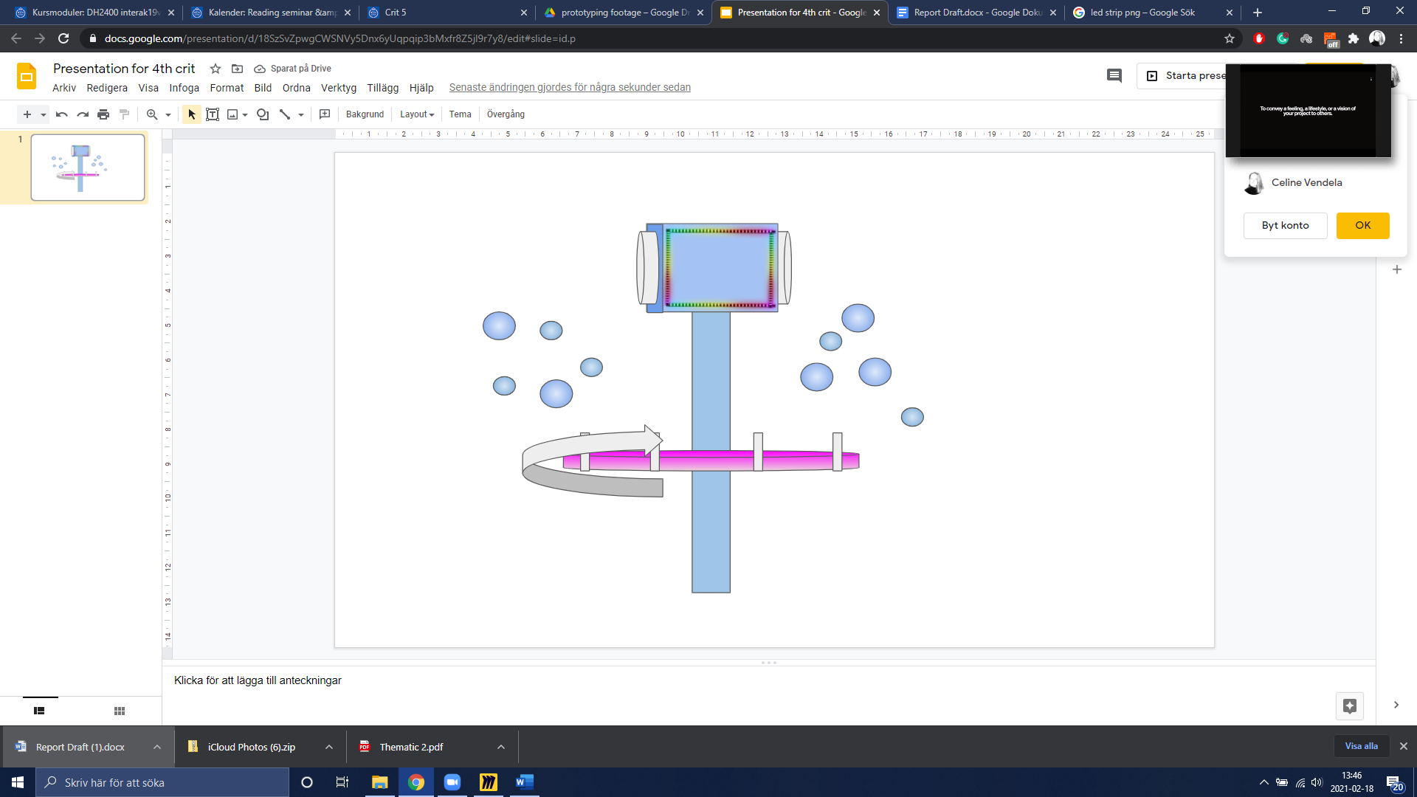

*Figure 4 The New design from iteration 2*

The tower body:  
The height of the device was determined to be around 200cm tall, in order to make the delicate parts unreachable by children. The pole holding the construction up will be made up of an internal rod from a solid material, e.g., metal, and around the pole will be the rotational part.

The bubble machine:  
The bubble machine is made of eight 3D-printed plastic hoops connected to a middle part that connects to the gear, as seen in Figure 5. The tray holding the bubble liquid is to be boat-shaped in order to make it possible to spin the construction. The bubble machine is purely mechanical and human-powered, it connects to the interactive part through a pair of 90-degree gears.

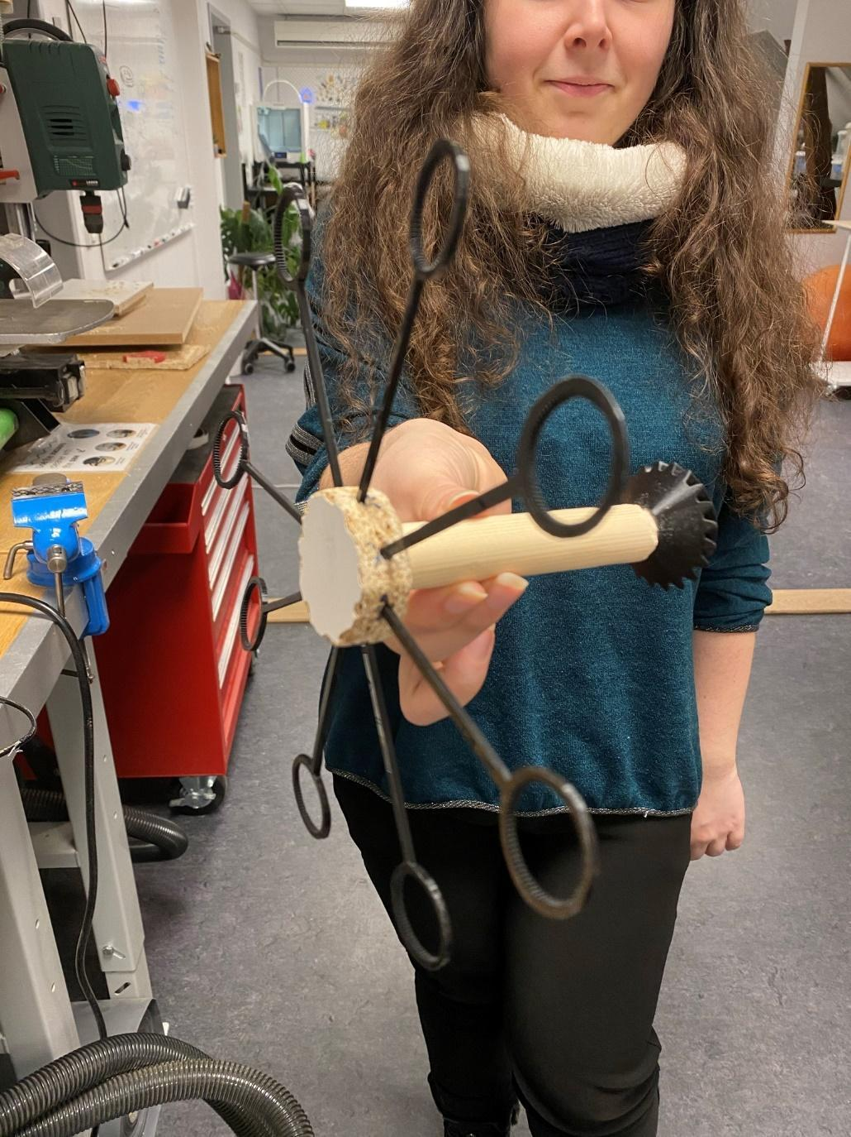

*Figure 5 Design of the bubble machine in second iteration*

Activation of interaction:

The fan and light will be activated with a button. The sensor-idea was scrapped as it would have made the machine much more complicated, and would be hard to implement without bugs. The spin is created with human power and is independent of the fan and lights.

Design and Security aspects:

The design is under debate, as the basic shape will be a box. We will work on the design when the

functionality-issues have been fixed. As for security issues, we have made the design tall enough not to be reachable by children. There is some concern about making the construction stable enough.

The soap:

A new recipe with *Head & Shoulders* shampoo is tested but turned out to work poorly. A trial was done with regular store-bought soap bubble liquid, and this was much more efficient, so we will likely buy ready-made liquid instead for the purpose of testing the functionality of the prototype and as a time-efficiency decision.

*Third Iteration (Final)*

The final iteration in the design process has many similarities with the second but includes a few changes due to trial and error testing and time-restraints. Figure 6 visualizes the intended final design that we developed, refined and redefined over the project lifecycle.

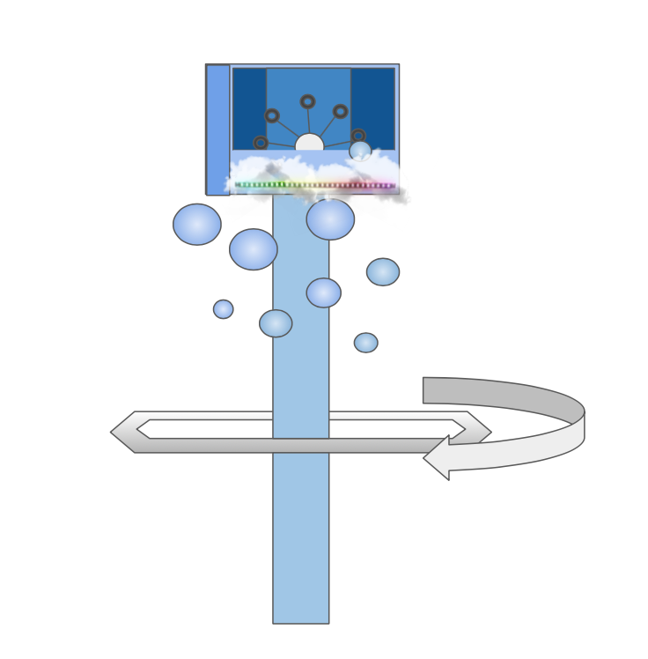

*Figure 6 Visualization of the final design of BubblePlay*

The Tower Body:  
The tower body will be approximately 200-220cm. The pole is made from rebar and the surrounding from a plumbing pipe. The hoop with which the bubble machine is spun is made from plastic pipes, cut and taped into a hexagon, see Figure 7. The implementation of this solution was not included in the end product of the equipment due to time restraints and we instead settled with directly holding on to and rotating the pipe manually by hand.

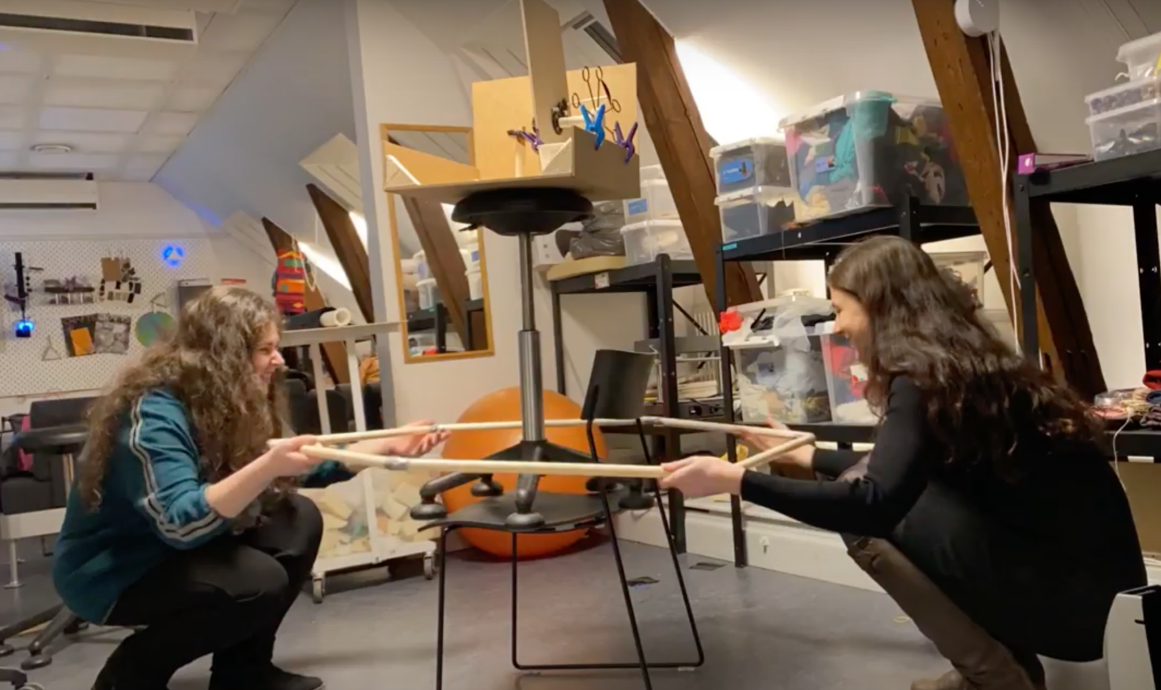

*Figure 7 Testing and roleplaying a potential user setting with the design. Imagining that the hexagon hoop would be used as a spinning wheel attached to the pipe for multiple users to collaboratively spin the bubble machine and enjoy the experience together.*

The bubble machine:  
The bubble hoops and its holder are the same as in iteration 2, but in this iteration, there was an attempt to implement a human-powered fan using connected smaller gears, see Figure 8, but this implementation did not work as the fan would not spin fast enough.

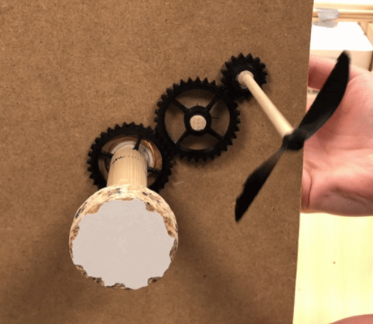

*Figure 8 The later scrapped gear solution for the fan.*

Instead, the decision was made to have the 3D-printed propeller fan be driven by a 9V battery connected to a DC motor. A solution for a pump-based air supply was discussed and investigated in this iteration, however as we were short on time we decided to keep the battery-powered fan. The 9V battery is held in a slot on the backside of the inner wall in the box, see Figure 9.

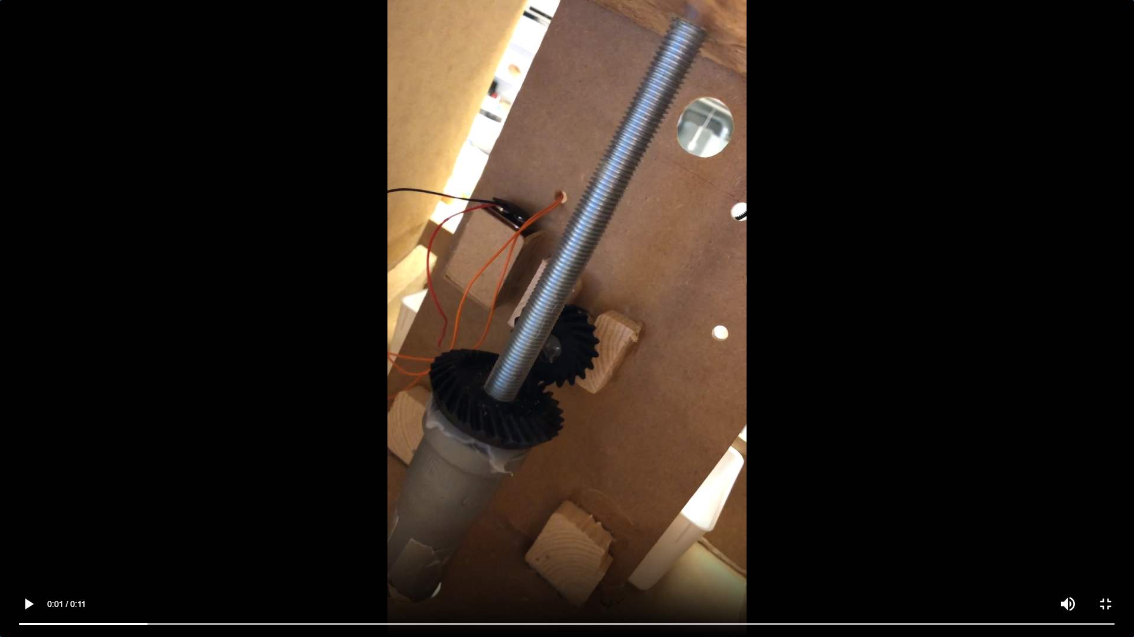

*Figure 9 The connection of the gears and the battery slot. Cables enter into the motor for the fan through the hole in the wall.*

In the design, there are two bubble machines, one on each side. However, in the finished product, we might only include one as the construction is quite time-consuming. We had a lot of trouble getting the gears to line up (see Figure 10 for gear placement) and the bubble hoop holder to spin properly, as the allowance on the sides for the wooden rod holding it allowed it to wiggle. This made the gear jump out of place and interrupt the mechanical motion. This was later solved by adding support to each side of the rod, making it stay in place for the gears to fit perfectly together, see Figure 9.

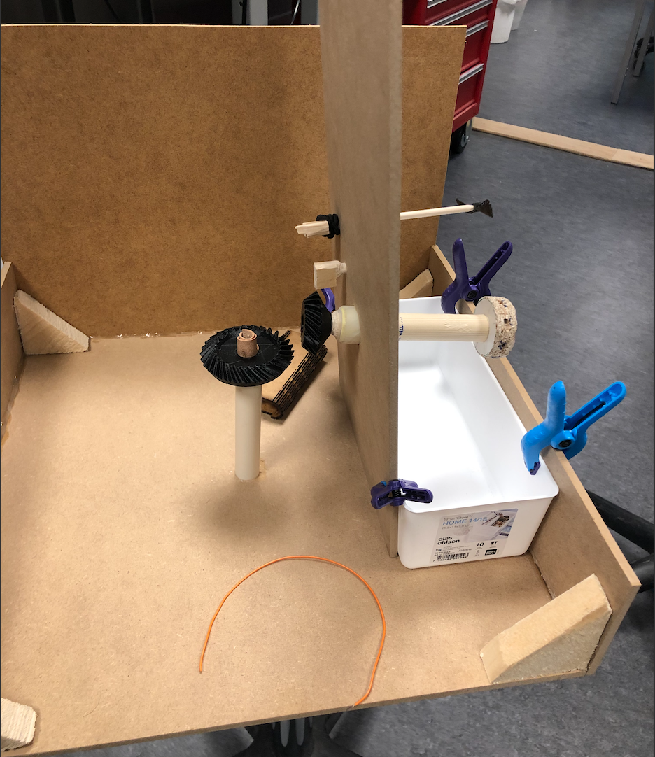

*Figure 10 Layout of the interior of the machine.*

Activation of Interaction:   
The fan and lights will be turned on with a button, the idea was to make a large one that can be pressed on with a foot, but the buttons available in the MIDDLA lab at KTH were not as easily fixed to the design as we had hoped for, and therefore it was exchanged for a simple flip-switch.

Design and Security aspects:  
The basic shape will be a box made out of MDF. The metal rod will stand in a parasol foot for stability. The LED-strips are attached under the opening where the bubbles exit and the box is covered with fluffy material to make it resemble a cloud, as seen in Figure 11. The LED-strip is controlled by an Arduino UNO, powered with USB connected to a power bank.

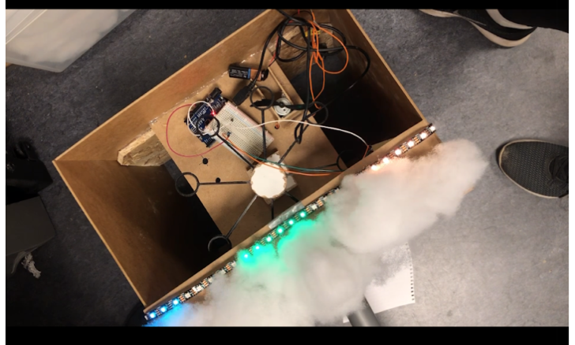

*Figure 11 Picture of the construction mid-decorating as seen from the front.*

After some feedback from the other students and the supervisors, we aimed to make one side of the box out of transparent plexiglass, in order to showcase the mechanics of the bubble machine. This was scrapped due to the lack of glue in the lab, and wood was used in order to be able to nail it together.

The Soap:  
A ready-made soap liquid of the brand *“Flying Tiger”* was used for the final test.

The final design implementation and the result of the project leading to the development of the product BubblePlay can be seen in Figure 12.

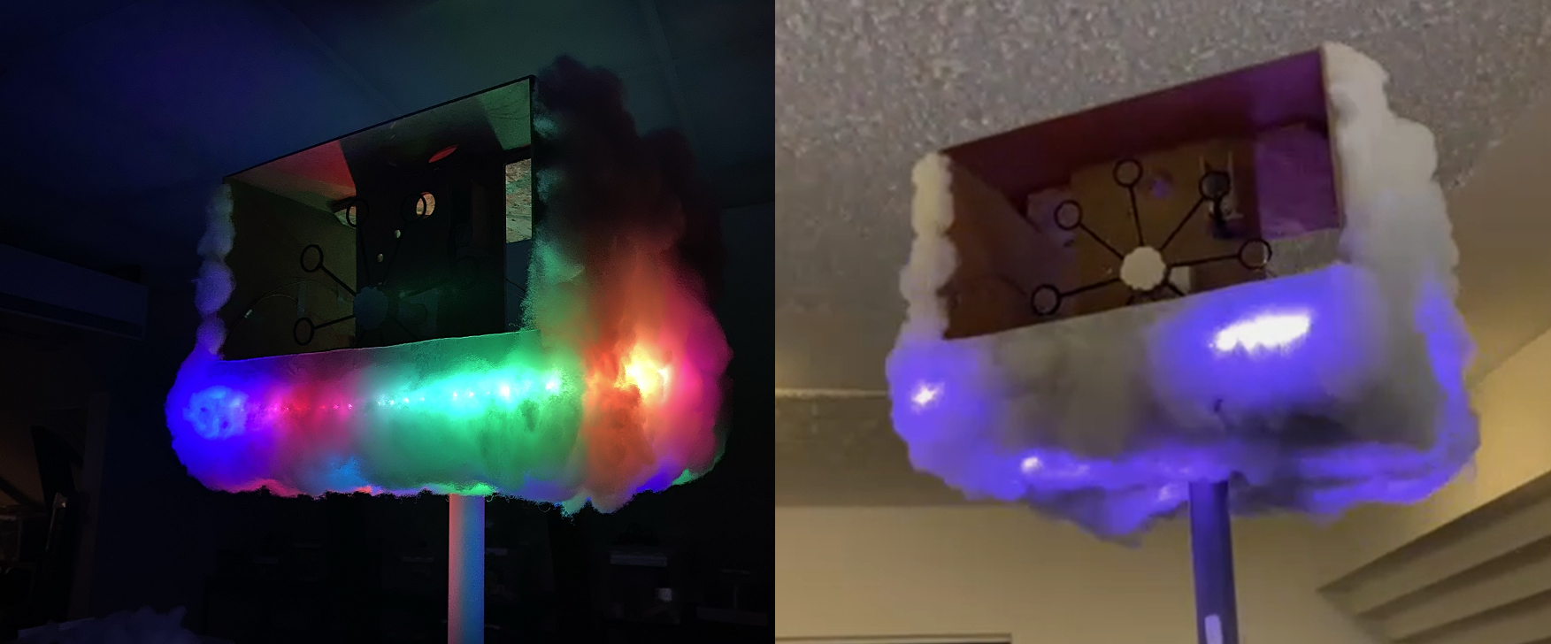

*Figure 12 Final version of the design and implementation of BubblePlay both in the dark and in a lighter surrounding.*

**Discussion**

Due to the pandemic, we could not travel freely in stores or by public transport. Therefore we had some trouble sourcing material for the machine and had to rely on what could be found in the inner city of Stockholm. We also encountered some issues regarding tools. Since we had limited experience in using the tools in the lab, and since not all tools we wanted were available, we sometimes had varying results when building. For example, the 3D-printing of parts took longer than expected, as we were not familiar with the programs used or how to alter the size of the printed model.

Since we wanted the bubbles to exit the machine fairly high, but still wanted to include the physical interaction of manually turning to produce bubbles, we were forced to rethink the design numerous times. The solution we ended up with, having a supporting rod in the middle of a rotating pipe with a gear on it, works fairly well, but since the construction was fairly top-heavy, it was also unsteady. A construction that allowed for the finished product to have a solid placement, or be placed on a surface or hung in a tree might have reduced this issue, but we did not have time to implement this in the scope of this project.

Since the bubble machine requires liquid, it would need to either have a heating device, or an automatic emptying mechanism for the bubble liquid. If the machine was built as a portable toy for e.g. daycares or kindergartens it would be ideal to let the container be removable for easy transport.

Unfortunately, we could not test the finished product with children as we wished to do. It was hard to schedule times after the prototype was finished, and due to the COVID-19 pandemic, we chose to adhere to recommendations in Stockholm County and not meet new people at this time. Instead, we did some roleplaying as we were testing the final prototype, and we are confident that it would have been popular with children. We were also unable to test it during winter conditions, as the weather had warmed up considerably when the prototype was finished.

**Conclusion**

Research for the prototype BubblePlay, a piece of interactive playground equipment for use all year round, brought some realizations. Firstly, there is a need for more interactive playground equipment at playgrounds, as it increases the engagement of the play for both children and potentially their guardians as well as improves their experience. Secondly, there is a need to encourage open-ended, full body, physical and social play and allow for guardians to join in on the play activity with these pieces of equipment together with their child and/ or children. Our finished prototype of BubblePlay fulfills these aspects, and even though we were not able to test it with our intended user group due to COVID-19 restrictions, we are confident it would be a piece of popular playground equipment for all ages.

**References**

[1] H. Acar, “Learning Environments for Children in Outdoor Spaces”. *Procedia - Social and Behavioral Sciences*, vol. 141, Aug 2014, p. 846–53. Latest accessed on: Mar. 17 2021, doi:10.1016/j.sbspro.2014.05.147.

[2] G. Bento, G. Dias, “The importance of outdoor play for young children's healthy development”, *Porto Biomedical Journal*, vol. 2, Sep 2017, p. 157-160. Latest accessed on: Mar. 17 2021, doi.org/10.1016/j.pbj.2017.03.003.

[3] D.G. Singer, J.L. Singer, H. D'Agnostino, R. DeLong, “Children's Pastimes and Play in Sixteen Nations: Is Free-Play Declining?”, *American Journal of Play*, vol. 1, 2009, p. 283-312. Latest accessed on: Mar. 17 2021, ISSN: ISSN-1938-0399

[4] L.E. Prino, M.A. Fabris and M. Settani, “Soap bubbles as a distraction technique in the management of pain, anxiety, and fear in children at the paediatric emergency room: A pilot study”, Child: Care, Health and Development Volume 45, 2018, Issue 2 p. 300-305. Latest accessed on: Mar. 19 2021. doi.org/10.1111/cch.12633

[5] J.R. Sharp, J.L. Maguire, S. Carsley, K. Abdullah, Y. Chen, E.M. Perrin, P.C. Parkin, C.S. Birken, “Temperament Is Associated With Outdoor Free Play in Young Children: A TARGet Kids! Study”, *Child Behavior,* vol. 18, May 01 2018, p. 445-451. Latest accessed on: Mar. 17 2021, doi.org/10.1016/j.acap.2017.08.006

[6] Z. Amouzegar, H.S. Naeini, R. Jafarian, “Design principle of playgrounds’ equipments and spaces for children: An interaction education approach”, *Procedia - Social and Behavioral Sciences,* Vol. 2, 2010, p. 1968-1971. Latest accessed on: Mar. 17 2021, doi.org/10.1016/j.sbspro.2010.03.265

[7] M.Talarowski, D.A.Cohen, S.Williamson, B.Han, “Innovative playgrounds: use, physical activity, and implications for health”, *Public Health,* vol. 174, Sep 2019, p. 102-109. Latest accessed on: Mar. 17 2021, doi.org/10.1016/j.puhe.2019.06.002

[8] J. Veitch, K. Ball, E. Flowers, B. Deforche, A.Timperio, “Children’s ratings of park features that encourage park visitation, physical activity and social interaction”, *Urban Forestry & Urban Greening,* vol. 58, Mar 2021. Latest accessed on: Mar. 17 2021, doi.org/10.1016/j.ufug.2020.126963

[9] W. Lee, Y. T. Hou, C. Zaga and M. Jung, "Design for Serendipitous Interaction: BubbleBot - Bringing People Together with Bubbles", 2019 14th ACM/IEEE International Conference on Human-Robot Interaction (HRI), Daegu, Korea (South), 2019, p. 759-760. Latest accessed on: Mar. 17 2021, doi: 10.1109/HRI.2019.8673265.

[10] ”Miro | Free Online Collaborative Whiteboard Platform”. Https://Miro.Com/, https://miro.com